Reclassification of the West Indian Manatee from Endangered to Threatened is Mandatory Based on CARRYING CAPACITY (CC) and OPTIMUM SUSTAINABLE POPULATION (OSP). Bob Atkins, Citizens for Florida Waterways

This comment addresses the current state of the of the West Indian Manatee population as compared to a calculated carrying capacity (CC) as a key indicator that the species is not Endangered. The commonly accepted definition of carrying capacity is the number of individuals an environment can support without significant negative impacts to the given organism and its environment. The emphasis here must include negative impacts to the environment as important to manatee managers.

The decision to list or not list or the determination of the correct classification must be based on the best scientific assessment of the health of the species considering specific criteria defined in the Endangered Species Act. It must not be based on popular opinion, political pressure, or how various clubs or organizations and their membership have adopted a specific species as their focal cause.

Species classification as Endangered or Threatened is based on any one or combination of the following factors:
1) The present or threatened destruction, modification, or curtailment of its habitat or range;
2) Over utilization for commercial, recreational, scientific, or educational purposes;
3) Disease or predation;
4) The inadequacy of existing regulatory mechanisms; or
5) Other natural or manmade factors affecting its continued existence.

Carrying Capacity (CC) is defined as the maximum number of animals an environment can support based on the available resources. Optimum Sustainable Population (OSP) is defined, with respect to any population stock, by the Marine Mammal Protection Act (MMPA) section 3(9). OSP is the number of animals, which will result in the maximum productivity of the population or the species, keeping in mind the carrying capacity of the habitat and the health of the ecosystem of which they form a constituent element. (16 U.S.C. 1362(3)(9)).

OSP is further defined by Federal regulations (50 CFR 216.3) as is a population size which falls within a range from the population level of a given species or stock which is the largest supportable within the ecosystem to the population level that results in maximum net productivity. Maximum net productivity is the greatest net annual increment in population numbers or biomass resulting from additions to the population due to reproduction and/or growth less losses due to natural mortality.

Clearly, for many species, CC will exceed OSP as the resulting and continued health of the ecosystem is a key factor in determining OSP but not CC. The West Indian Manatee has shown adaptability to almost any aquatic environment that it can swim into, as long as the water temperature remains 68F or above.

The critical habitat elements are temperature above 68F, available fresh water sources and submerged aquatic vegetation (SAV). Therefore, CC is only limited by warm water capacity, SAV, and available fresh water. For the manatee, these are the only naturally occurring and constantly present limitations to population – or in other words the elements defining CC.

The greatest danger of continued mis-classification of the manatee is the inability to actually apply any measures of population control or containment even as the population exhibits continual increase – ultimately reaching OSP - or potentially surpassing even surpassing OSP and reaching CC. The Endangered classification requires a management approach consistent with a depleted species. Per language of the ESA and the Marine Mammal Protections Act (MMPA), the USFWS is compelled to continually manage and regulate to increase the manatee population.

Unfortunately, there is little change in allowable management approaches between Endangered and Threatened. Reclassification to Recovered is required to actually implement any measure of population controls for any species listed in the ESA which is also included in the MMPA. Because the threat of local area manatee overpopulation far exceeds any threat of extinction – or even ‘quasi-extinction’, the manatee should be reclassified as Recovered as soon as possible.

We at CCFW are not cognizant that an accepted value for overall CC has been calculated. There has been some research as it relates to CC. All of the research found by CFFW has been more specifically targeted a top-down statewide or habitat wide CC. Alternatively, this overall CC might be more readily determined by collectively determining and combining local area CCs. These local area CCs may actually have more significant value to species managers in their decision processes on specific actions, both regulatory and stock management, since the impact on the ecosystem by the manatee population size may be more critical in one local are vs. another.

For example, it may be a good management decision to eliminate the warm water outflow from a particular manmade source and not others based on the local area population comparison to the local area carry capacity. While in another area, such a decision might clearly be detrimental in light of a locally limited population.

One of the concerns with manatee management is that this species is capable of exceeding CC. That is, the manatee population has the capacity to continue to grow, even beyond the ability of the environment to thrive as a healthy ecosystem for other shared species. At some point, even the manatee population would experience sudden and catastrophic decline, but the ecosystem may have been all but destroyed prior to reaching that event.

This comment will look at some localized CC numbers and compare that to the associated local area population. As we will discuss and illustrate, the CC is greater than the OSP. This approach to determining CC and the results can be extrapolated to the entire manatee habitat by simply applying the methodology to a well-defined collection of local areas and then combining the results. The conclusion is clear. In the local area of the Indian River Lagoon (IRL), the West Indian Manatee population is consistently increasing at a positive rate. Without some natural catastrophic event or significant change in our management approach, this population, which is at or near OSP, will likely exceed the OSP or worse yet, continue to increase toward the total CC. The near certainty of this outcome is nearly three orders of magnitude greater than the likelihood of the manatee population reaching ‘quasi-extinction’ (0.1% probability) over the next 100 years.

When Michael C. Runge, USGS Patuxent, presented the summary of analysis and results of the latest applications of the USGS Manatee Core Biological Model (CBM) to the Manatee Forum in May 2013, he showed manatee population predictions for the next 100-150 years as well as the projection in each of the four sub-regions. The representatives of USGS And USFWS praised the Manantee CBM as the most sophisticated species model developed to date. Runge’s presentation of results is the source of the ‘quasi-extinction’ prediction above and is illustrated in this graph.

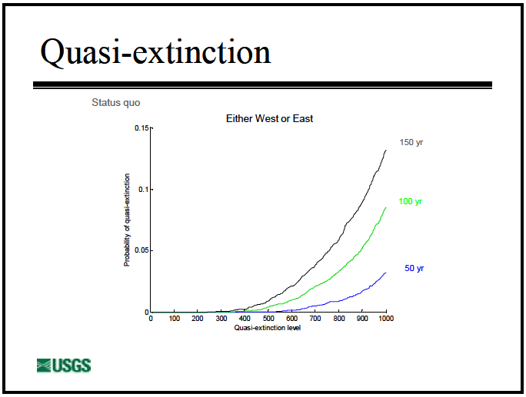
Source: Manatee Threats Analysis, Michael C. Runge, USGS, presented
to the Manatee Forum, May 2013
Also included in the CBM analysis were limitations of the statewide warm water capacity and its affect on manatee population predictions. Runge showed the
greatest upper bound of the warm water capacity at around 32,000 manatees and decreasing to around 20,000 over the next 100 years and the lowest lower bound at 10,000 decreasing to around 4,000 manatees over the next 100 years. While the potential for loss of the manmade warm water outflows near the power plants is a matter of policy and regulatory decision making, the predicted future decreases in natural warm water capacity are simply theoretical.

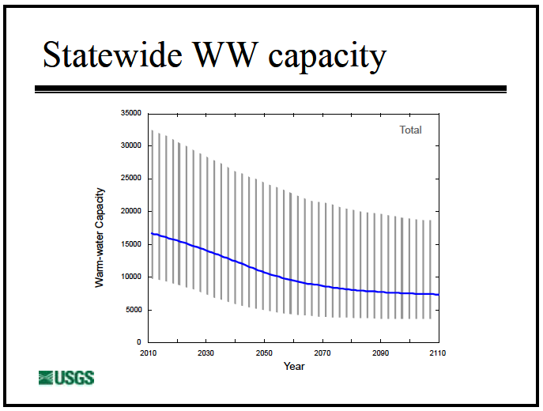
Source: Manatee Threats Analysis, Michael C. Runge, USGS, presented
to the Manatee Forum, May 2013
Incorporating the theoretical decreasing warm water CC into the long-term manatee population 100 year growth predictions illustrated a statewide maximum upper bound of around 25,000 and a minimum lower bound around 5,000 animals. The CBM gave a likely prediction of sustaining growth based on a current population level around 5,000 with steady growth over the next 50 years and reaching a state wide population of 10,000 that would level off due to the limits of the theoretically decreasing warm water CC.

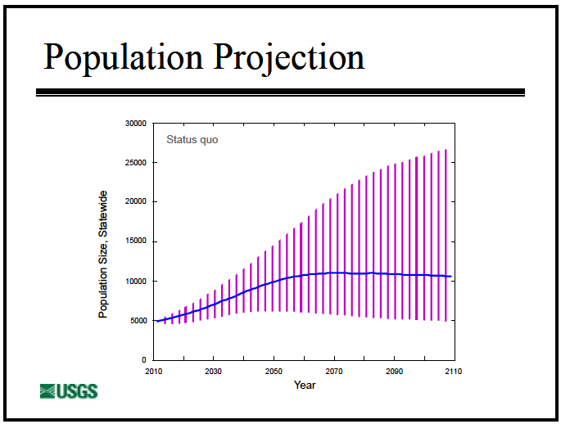
Source: Manatee Threats Analysis, Michael C. Runge, USGS, presented
to the Manatee Forum, May 2013

Further, the CBM provided individual modeling predictions for the four regions. One region (Northwest) appeared to be unbounded while the other three exhibited approximate greatest upper bound as follows:
Atlantic 4000
Southwest 4000
Upper St. Johns 6000

Looking at the combined predicted population values, we again see the population leveling off at around 10,000 animals due to warm water CC.

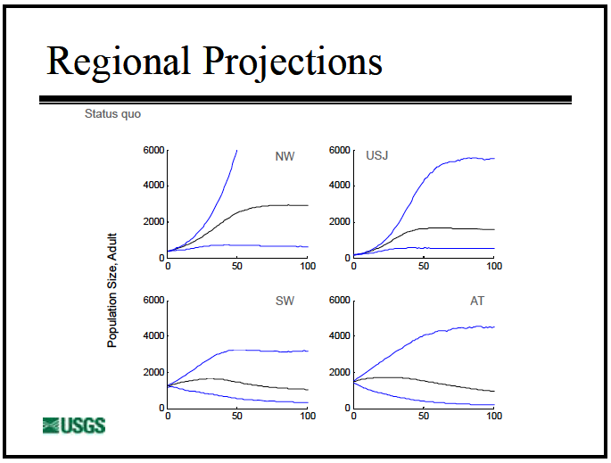
Source: Manatee Threats Analysis, Michael C. Runge, USGS, presented
to the Manatee Forum, May 2013

Looking at the combined predicted population values, we again see the population leveling off at around 10,000 animals due to warm water CC. These numbers have direct relevance to the overall statewide/regional manatee CC but only from the perspective of warm water capacity. This look at CC does not include any limitations with respect to forage.

For those who might argue that human activity, such as mortality attributed to watercraft, or who might also conjecture that a sudden change in the historically observed frequency of red tide events has an impact on overall population or even more implausible, on OSP or CC, one need only look at the following summary charts from the CBM to see that these events have been incorporated into their effects have been calculated in the CBM predictions. In fact, if for example, all man made mortality due to watercraft were immediately eliminated for all time the affect on the prediction of ‘quasi-extinction’ would be about of a percent (0.06%) improvement over the previously stated probability of 0.10% reducing the probability of quasi-extinction prediction to .094%. Red tide elimination would improve probability of quasi-extinction by 0.64%, further reducing the 0.10% probability of ‘quasi –extinction to 0.036%. These are negligible impacts and therefore watercraft and red-tide considerations are not relevant to calculations of OSP or CC.

Source: Manatee Threats Analysis, Michael C. Runge, USGS, presented
to the Manatee Forum, May 2013

In June 2012, Provancha, et al, published Carrying Capacity Assessment of Manatee Forage and Warm-water Associated with Eleven Florida Sites which was submitted to the USFWS by Innovative Health Applications, LLC (IHA). Even though the intent of the study was to examine warm water CC, the authors recognized the availability of nearby SAV for forage as another primary consideration in determining the limits on CC.

This IHA study examined warm water CC while evaluating these two basic limiting capacities:
1) What is the Site capacity? (How many manatees could volumetrically gather in the warm refuge?)
2) What is the Forage capacity of the nearby available SAV.

The eleven sites studied by the IHA group are probably the most significant natural sources of warm water in the overall manatee habitat. Understanding the CC associated with them is of importance due to the long-term potential shut down of some or all manmade warm water outflows found at the various power plants throughout the manatee habitat. Each site was evaluated for Site CC and Forage CC using multiple 10,000 trial Monte Carlo simulations of ranges of input variables relevant to the site and the forage. The lower of the predicted CC determined whether the site was limited by volume of warm water the nearby availability of SAV.

When taken at face value, the IHA study suggests that the combined CC for these eleven sites is around 18,500 manatees, but further investigation shows that the site limited CC for Crystal River (13,725) comprises 74% of the calculated total CC. All of these values are the median (50 percentile) results from separate 10,000 trial Monte Carlo simulations.

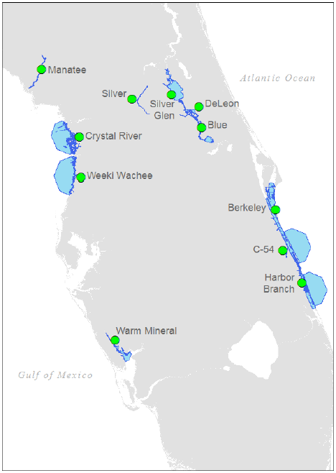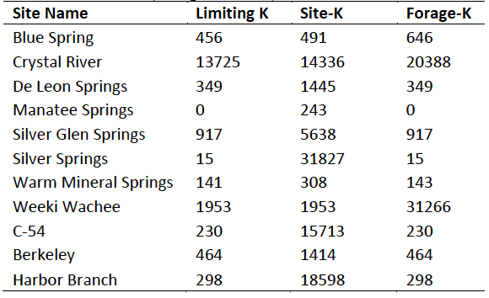
^{Source: IHA Study}
Note that the IHA Study uses K for carrying capacity.

Further evaluation reveals that 8 of the 11 sites were determined to have a CC (shown as K) limited by available forage (SAV within a 30km radius of the site), and not limited by warm water. Four of these sites (Crystal River,
Weeki Wachee on the west coast and Sebastian River/C-54 Canal and Harbor Branch on the east coast) were close to an ocean inlet, so and the IHA team proposed the 30km available forage radius extended nearly 30km offshore. This results in the inclusion of large areas of SAV, never used by manatees, into the forage calculations. The SAV beds offshore Citrus County (the Crystal River site) have the most pronounced (and unlikely) impact on the CC assessment.

As recently as 2003, USFWS was making policy and regulatory decisions based on the now outdated premise that warm water refugia was THE limiting factor for manatee carrying capacity as evidenced by this quote directly from the Federal Register: May 8, 2003 (Volume 68, Number 89), Proposed Rules, Page 24700-24704 in reference to: Fish and Wildlife Service ACTION: Proposed rule; withdrawal. Availability of Record of Decision; 50 CFR Part 18; RIN 1018-AH86; Marine Mammals; Incidental Take During Specified Activities.
“New information about carrying capacity suggests that it may decline over the next 3 to 60 years, which would affect density-dependent life history and management functions of the Florida manatee. The limiting factor for the carrying capacity of each stock is warm water refugia. Each stock of Florida manatees is variably dependent on natural and artificial warm water refugia, such as springs, sewerage outfalls, and power plant discharges. Preliminary information presented in the Incidental Take Model, but not yet peer reviewed, suggests that a reduction in total warm water carrying capacity is possible, if not likely, in the near future. This would suggest that OSP will change over time. Our implicit assumption of a stable OSP is challenged by this information. This, in turn, has implications for our interpretation of total population estimates, and our assumption that none of the stocks were severely depleted based on the demographic benchmarks.”
With the Crystal River site removed from the analysis, the estimated CC of the remaining 10 sites was merely 4832, with 8 sites limited by nearby forage and 2 limited by warm water volume. Clearly manatee carrying capacity is more strongly limited by forage than by warm water refugia, as previously believed and used as the basis of determination of OSP as well as CC.

The most important and consistent message from both of these independent and diverse analyses of the manatee species is that there are upper bounds to manatee population, which are the naturally occurring features of the habitat itself. Further, the previous fear that anticipated losses of warm water, which have not occurred in the 11 years since, have had no adverse affect on population growth. In both of these analyses, the determined upper bounds of the population are less than 25,000 and more likely around 10,000, if you only consider available warm water outflows. When we consider SAV as a potential limiting factor, the numbers are further reduced as indicated below.

The IHA Study input variables in the simulation analysis with respect to SAV were:
1) m² of SAV coverage within a 30 km radius;
2) SAV density (kg/ m²), and;
3) SAV winter growth rate in days.
The IHA study concentrated on a sustainable period of 120 days based on an extended winter. SAV coverage was based on expert input. The assumption for growth was full SAV regrowth rates of 100 – 192 days and the SAV biomass range was 7,003 to 14,453 lbs(wet) / acre. These values are a direct conversion from the values found in Table 1 of the IHA study, reproduced here.
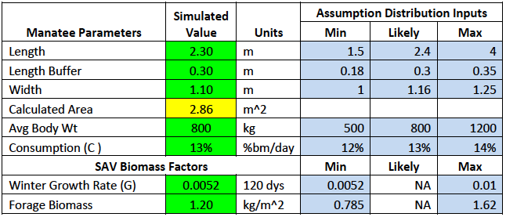
^{Source: IHA Study}
Because of the relevance and consistency with the results of the our own analysis of the local area CC for the Indian River Lagoon, the results for three of the sites in the IHA study are included here. These are the Sebastian River / C-54 Canal area, Berkeley Canal, and Harbor Branch Canal.

All three sites were determined to have SAV limited CC. Collectively, the 30km radius around these sites overlaps to include all areas of Sykes Creek, all of the Banana River into the northern Federal Restricted Zone, and the Indian River – from just south of SR 520 (Cocoa) to around 20 km south of Ft Pierce inlet. The figure below, taken from the IHA study, illustrates the actual upper and lower extremes of the IRL and highlights the areas evaluated by the IHA study.
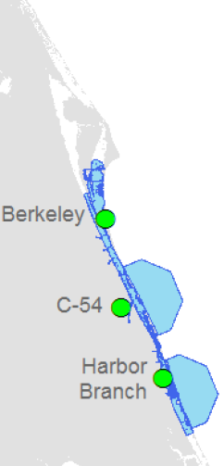
The following table illustrates the some specific percentile values for the 10,000 simulation runs of the IHA Study for each of the IRL sites. Each of the values are the limit to the total number of manatees resulting from the 10,000 trial Monte Carlo analysis of the IHA study. These values were all limited by available forage (SAV). The 0 and 100 percentile values bound all of the 10,000 results. One should note that at 90 and clearly at 100 percentile, the end condition is such that ALL available forage has been consumed. One MUST consider the dire consequences this implies for the IRL ecosystem.

Therefore, 100 percentile population predictions clearly are equal to or exceed the local area CC. The 50 percentile results represent the median (half of all results smaller and half larger). The IHA Study authors chose to analyze CC based on the 50 percentile results. One could argue that these values are valid determinations of the OSP for these areas.

One should be cautious that these numbers, the analysis must be considered extremely optimistic, if not completely biased toward large value results. This is due to the fact that the regrowth rate range (100-120 days) makes no provision for extended regrowth (years) due to some percentage of the SAV having been uprooted during grazing and not immediately capable of regrowth. We also note that other lesser estimates of SAV density exist. The St Johns River Water Management District (SJRWMD) estimates that the SAV density in the IRL is more on the order of 1400 – 1500 lbs per acre, not the 7,000 – 14,000 range in the analysis.

Site | 0 Percentile | 50 percentile | 90 percentile | 100 percentile
C-54 | 145 | 230 | 349 | 640
Berkeley | 294 | 464 | 706 | 1419
Harbor Branch | 189 | 298 | 451 | 844
TOTALS | 628 | 992 | 1506 | 2903

Even by including all of these optimistic assumptions in the calculations of the model, then somewhere between 1,500 and 3,000 animals living in this extended area would push the limits of the local area CC to the point that we would expect to see negative impact on the amount SAV in these areas of the IRL. The IHA Study establishes that the CC for this area is forage limited (not warm water) and implies that the OSP is around 992 animals.

What the study does not say is that the population will not exceed 992 animals. In fact there is no controlling factor to insure that the local population will not exceed 992. Statistically, there is available forage beyond the needs of 992. But, since the IRL is an ecosystem whose life-blood is SAV, can we allow one species to reach a population that threatens to deplete the SAV beyond its ability to sustain an equilibrium state where SAV is not constantly depleting? This event risks the loss of the IRL ecosystem itself? One must consider the sustainability of the SAV, the basic element of the ecosystem habitat in any discussion with respect to OSP.

Clearly, the IHA study establishes an effective approach for evaluating and estimating both OSP and CC on a local area basis. By applying the methodology of the IHA study to a mutually exclusive collection of local areas that span the manatee habitat, one can extend this approach to achieve reasonable calculations of overall OSP or TOTAL CC for the entire population within the habitat.

CFFW first posed the question of CC to the State and Federal wildlife managers in the mid 80’s and has continued to ask this question over and over. The latest attempt at getting this critical question addressed was in the framework of four questions submitted to the agencies in late 2013. These questions were and are relevant to the ongoing crisis in the IRL which is most observed by the significant and continued loss of SAV acreage and the continued increase in nutrient content in the IRL.
1) What is the average annual production (by weight) of an acre of seagrass producing estuary bottom?
2) What is a good value for average consumption of seagrass (by weight) for the average manatee in a given population?
3) What percentage of seagrass intake results in excrement?
4) What is a reasonable chemical decomposition of manatee excrement?

The Florida FWC provided some valuable data in response to 1-3. We continue to wait for any data relative to question 4. CFFW initiated an assessment of the response to questions 1) and 2) in combination with the analysis of SAV coverage in the IRL determined by the St John’s River Water Management District (SJRWMD) to perform an independent analysis of the Carrying Capacity of the IRL.

So what is the CC for the IRL? Based analysis and results of the IHA study, CFFW would define CC in terms of the upper bound of the population without regard to the sustainability of the habitat. We would define the OSP as that population level which can be sustained by the habitat without risk to the habitat. Therefore the OSP must be such that there is reasonable margin between it and CC which can be jointly managed by both manatee and habitat managers.

In May 2014, CFFW presented A Look at Manatee Carrying Capacity in the IRL to the Manatee Forum. Although the perspective and approach of this analysis was vastly different from that of the IHA study, the findings are surprisingly consistent.

The IRL s defined as the system of interconnected Atlantic coastal estuary, bounded by Ponce de Leon Inlet to north and Jupiter Inlet to the south. For the purposes of the analysis that follows, we will use Ft. Pierce Inlet as the southern boundary. This is simply because the SAV coverage estimates for this more limited area are readily available from the SJRWMD. These estimates are:
YEAR Acres SAV
2007 84,000
2009 73,000
2011 41,000

Florida FWC provided a wide range of estimates for seagrass density/production in the IRL:

SOURCE Production/Density (wet lbs / acre / year)
Short, et al - 1993 6210
SJRWMD - 1996 – 2010 1446
Provencha, et al – 2012
(the IHA Study) 7003 –14454

FWC also provided that an average manatee is 1,000 lbs and consumes 4 – 9% of body weight per day which equates to 42 – 94 wet lbs / day.

By comparison, Table 1 of the IHA study assumed 800kg with a simulation range of 500-1200kg. (since this translates to a range of 1100-2640 lbs, we assume the IHA study meant to express manatee weight as 500 - 1200lbs). Based on this correction and assuming 12 – 14 % body mass as daily intake, the IHA study used a consumption range of 60 – 168 wet lbs /day. If one were to assume the weight estimate is actually expressed as kg, the consumption range would be 132 – 370 wet lbs/day. These values are outside any previously acceptable consumption rates.

How many acres of IRL seagrass are required to sustain one healthy manatee for one year? Looking at minimum consumption combined with maximum SAV production we get:
42lbs x 365 days x acre = 1.06 Acres of Seagrass /yr
day year 14,500 lbs

Looking at maximum consumption combined with minimum SAV production we get:
94lbs x 365 days x acre = 23.7 Acres of Seagrass /yr
day year 1446 lbs

So we have developed upper and lower bounds for acreage of SAV to sustain 1 manatee for 1 year. Admittedly this is a wide range, but that is a direct result of the wide range of SAV production estimates.

Unlike familiar land grazing mammals such as horses, cows and sheep, the manatee has teeth in the front of it jaw. Therefore it has no ability to bite grass off and only weak grass will break off in the manatee split gum front jaw. As the manatee tugs and pulls at SAV, a significant percentage is pulled up by the roots leaving bare bottom. How long does it take this bare bottom to replenish. In the observation of CFFW, – it NEVER grows back – but to be conservative, we have chosen to use a four year regrowth term.

Depending on the estimate used for bare bottom regrowth, the acreage that is consumed in the first year will not replenish for the number of years determined. One must multiply the minimum acreage to sustain 1 manatee for 1 year by a factor of the number of years which the reader feels is reasonable to determine the minimum number of SAV acres to sustain 1 manatee indefinitely.

Using 4 years, yields upper and lower bounds of 4.24 and 94.9 acres of SAV for long term sustained health of 1 manatee. One can argue whether this is the best approach to find the CC of a local area. For the IRL, with 41,000 acres of seagrass available, this would imply a CC is bounded between around 432 and 9700 manatees. These numbers are comparable in both principle and magnitude to the 0 (628) and 100 (2906) percentile values in the IHA Study considering the extended range of the IRL beyond the range of the areas evluated in the IHA study.

The problem with this calculation is that we have assigned ownership of all the SAV to the manatee. An OSP must survive without detriment of its habitat. In this case the SAV is the habitat for part of the life cycle of every living creature in the IRL. So again, conservatively, let’s assign 50% of the SAV to the manatee and leave 50% un-impacted by manatee forage and available for the survival of all other creatures in the ecosystem. This would bound the OSP roughly between 215 and 4800 manatees.

But remember – these are boundary values and the closer we get to 4800 the more likely we are putting the IRL at risk since the upper bound assumes minimum consumption and maximum SAV production.

So the obvious question becomes: What is a realistic value for Carrying Capacity and or Optimum Sustainable Population? Without access to the Monte Carlo model employed by the IHA study, CFFW chose to select a set of reasonably supportable values for SAV consumption and IRL SAV production and determine the results based on these values.

We chose the midpoint of the 42-94lb range used for consumption rate per day – 68 lbs. One must to be skeptical of the 10-fold range of values provided by FWC for SAV production. These rates range from 1,446 (SJRWMD) to 14,500lbs (IHA study max) per acre. Clearly there is opportunity for some future analysis, but if one were to use the Short, et al estimate of 6,200lbs per acre, that would be 4 times the SJRWMD estimate of 1,446 and nearly half the IHA / Provancha maximum of 14,500. So we chose 6,200 lbs /acre for our test case value.

The resulting numbers would be as follows:
Consumption: 24,800lbs seagrass / year / manatee
Production: 6,200lbs seagrass / acre / year

This equates to 4.0 acres of SAV for 1 manatee to survive 1 year
16 acres for sustained survival of 1 manatee (4 year regrowth estimate)
32 acres for sustained health of 1 manatee without detriment to the IRL

based on these values and the estimated 41,000 acres of SAV,
The IRL can sustain 1280 manatees and remain viable (OSP)

This is very consistent with the results of IHA Study 50 percentile value of 992 for the southern and central areas of the IRL.

The 2012-13 Brevard County manatee counts performed by FPL averaged 963 animals with a high count of 1719 manatees. The 2013-14 FPL counts averaged 1392 animals with a high count of 1966 manatees.

SJRWMD estimated the 41,000 acres of SAV remaining in 2011 decreased to 25,000 acres in 2012. SAV estimates for 2013 are not available at this time. SJRWMD indicated that they will not be available until late August or early September 2014.

Clearly, these two independent analysis of CC and OSP indicate that the current observed conditions in the IRL with respect to manatees resident and available SAV are converging rapidly to and potentially beyond the local area manatee OSP.

Since the species has exhibited a 40-year history of population growth and resilience to all threats, there are no natural or manmade factors that can be cited that could affect the species continued growth. Moreover, one can only reasonably expect the population to increase to the limits of the collective carrying capacity to the detriment and potential destruction of the habitat itself.

The conclusion is clear. We are closer to the OSP in the IRL than we previously believed. If we do nothing to manage this local area population, we risk allowing the IRL SAV to decline to levels that no one wants to imagine. If we do not reclassify the manatee from Endangered to Recovered, we are trapped by the MMPA and the ESA to continue to implement policies and regulations that have one singular goal – “More is Better”. The IRL cannot survive this management approach indefinitely. As the IRL SAV goes, so goes the local manatee population and the habitat of all the other species that claim the SAV for habitat during a portion of their life-cycle.

We find ourselves facing a paradox similar to the one identified by the USFWS in the again in 2006 when considering the Upper St Johns manatee subpopulation. That is the very real possibility of the species subpopulation reaching OSP before it is classified as Recovered. Now we see this very real possibility for a critical percentage of the Atlantic subpopulation. If this happens the manatee mangers will not be able to meet the criteria for Recovery because the population will not be growing at a fast enough pace.

A different paradox arises from the circular argument that reductions in SAV mean reductions in habitat which implies continued classification as Endangered which is implies a depleted population which demands population growth measures fo manatee management, which continues to pressure the SAV and further reduce the habitat - and so on. Reclassification to Threatened is a step in the right direction, but reclassification to Recovered needs to follow in the near term so that proper management approaches can be implemented that favor the IRL ecosystem specifically and the overall habitat in general above and beyond that of a singular species.

