Reclassification of the West Indian Manatee from Endangered to Threatened is Mandatory Based on Best Practices of Risk Management - Bob Atkins, Citizens for Florida Waterways

This comment addresses the contradiction of current of manatee management practices with best practices of Risk Management. This contradiction is a direct result continued classification of the manatee as Endangered. Endangered means a stock is dangerously depleted and all effort must be made to Recover the depleted stock. Failure to recognize the Recovery of the species in a timely manner has lead to this contradiction.

Unfortunately, with respect to manatee management, the USFWS decision-making has been adversely affected by public pressure from a small group of special interest groups. In this case, a series of bad decisions started and continues to be driven by an agreement to respond to a threatened lawsuit from these groups by out of court settlement. This settlement and continued pressure brought by these groups has lead to a dichotomy between politically motivated actions and scientific based needs.

Sound risk management starts with an effort to identify all elements of risk. This task in itself can be arduous. In many instances, one cannot eliminate all risk. The next step is to prioritize all risks in order to manage overall risk more efficiently. Many times we hear comments within the manatee management group that are basically an identification of one risk or another. These risk related subject comments include loss of warm water, loss of habitat, collision with watercraft, occurrences of outbreaks of toxic red-tide, and sudden onslaught of extreme cold weather, to name a few.

All of these are related to the historically most relevant risk for the manatee species – the risk of extinction. Continued classification as Endangered forces the risk of extinction continues to be the risk of highest priority.

Recently, Michael Runge of USGS provided an the output of the manatee core biological model (CBM) as in input to the USFWS manatee tock assessment. This CBM is reported to be the most sophisticated population modeling tool developed to date. The primary output of the CBM was that based on current population size, adult survivability rates, reproductive rates and the influence of various threats such as watercraft, warm water, red tide, and others is that probability of ‘quai-extinction’ over the next 100 years is less than 1/10 of 1% (0.1%).

Due to concerns by the expressed concerns by some within the manatee management community, Runge included a set of analyses that address the level of risk associated with the various perceived threats to manatee survival. The results of these analyses and the potential risk associated with each individually and collectively illustrated in the chart below. Note that even when considered over the next 150 years, these threats do not significantly impact the probability of ‘quasi-extinction’ one way or another.

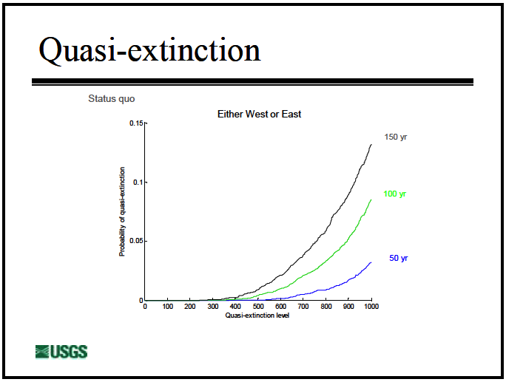

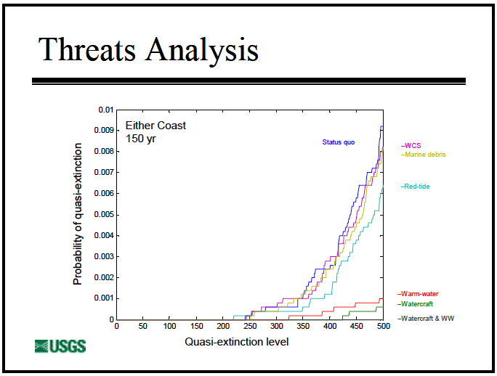
Source: Manatee Threats Analysis, Michael C. Runge, USGS, presented to the Manatee Forum, May 2013

Industry standard Risk Management practices have application to all types of situations and decision-making especially when developing strategic planning. There are many forms of risk management matrix, but the following 3x3 matrix suffices to illustrate the how different our management practices would be if we based them on the most basic of risk management practices.
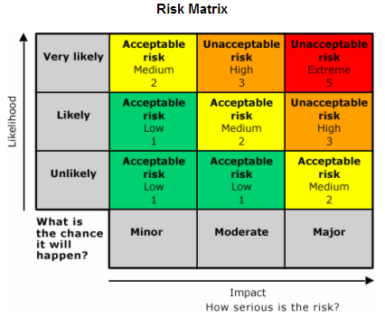
likelhood of manatee extinction
So what the collective data from two consecutive stock assessments including the CBM analysis (the best available science) establishes beyond any reasonable doubt is that the threat of manatee extinction is highly unlikely. When we look at this with respect to the basic risk management matrix, this places this risk of extinction well within the bottom region of the bottom row of the matrix below. Therefore no matter how serious you may feel that the consequence of extinction is, the risk is clearly classified as acceptable.

On the other hand, there there is also a potential risk of over-population. This occurs if the population exceeds the optimum sustainable population (OSP) and continues to grow to carrying capacity (CC).

All available data indicates that the manatee population has grown at a rate of 5-7% over the last 40 years. Without some form of management intervention, this population will continue to increase until it reaches some natural limiting factor. As late as 2003, it was clear that USFWS believed that this limiting factor was available warm water volume. This is clear from the following excerpt:
Federal Register: May 8, 2003 (Volume 68, Number 89), Proposed Rules, Page 24700-24704 in reference to: Fish and Wildlife Service ACTION: Proposed rule; withdrawal. Availability of Record of Decision; 50 CFR Part 18; RIN 1018-AH86; Marine Mammals; Incidental Take During Specified Activities.
“New information about carrying capacity suggests that it may decline over the next 3 to 60 years, which would affect density-dependent life history and management functions of the Florida manatee. The limiting factor for the carrying capacity of each stock is warm water refugia. Each stock of Florida manatees is variably dependent on natural and artificial warm water refugia, such as springs, sewerage outfalls, and power plant discharges. Preliminary information presented in the Incidental Take Model, but not yet peer reviewed, suggests that a reduction in total warm water carrying capacity is possible, if not likely, in the near future. This would suggest that OSP will change over time. Our implicit assumption of a stable OSP is challenged by this information. This, in turn, has implications for our interpretation of total population estimates, and our assumption that none of the stocks were severely depleted based on the demographic benchmarks.”
As long as warm water was believed to be the limiting factor for CC, there was no concern over any consequence to habitat if the manatee population actually reached the CC of the ecosystem. We simply would reach an equilibrium where the volume os warm water would limit the umber of manatees that would not be subject to cold stress mortality. In this case, the OSP and the CC would essentially be the same.

But OSP is defined, with respect to any population stock, by the Marine Mammal Protection Act (MMPA) section 3(9). OSP is the number of animals, which will result in the maximum productivity of the population or the species, keeping in mind the carrying capacity of the habitat and the health of the ecosystem of which they form a constituent element. (16 U.S.C. 1362(3)(9)).

In June 2012, Provancha, et al, published Carrying Capacity Assessment of Manatee Forage and Warm-water Associated with Eleven Florida Sites which was submitted to the USFWS by Innovative Health Applications, LLC (IHA). Even though the intent of the study was to examine warm water CC, the authors recognized the availability of nearby SAV for forage as another primary consideration in determining the limits on CC.

The importance of this study is that it forever changes the underlying assumption that warm water refugia is the limiting factor for CC. This study established that

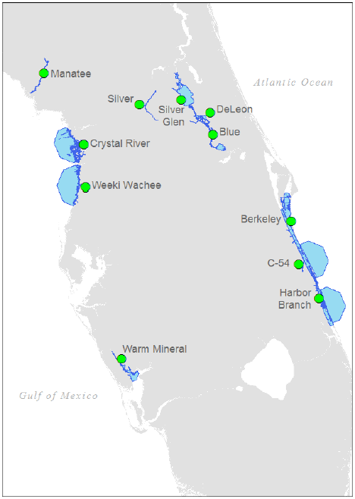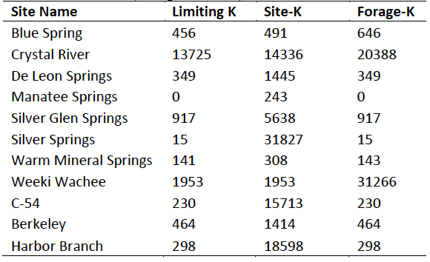
Source: IHA Study. Note that the IHA Study uses K for carrying capacity.

available forage, submerged aquatic vegetation (SAV), was a more limiting factor than warm water. These graphics, taken directly from the study, indicate the 11 natural warm water refuges that were evaluated by the IHA study
team. The blue shading indicates the 30km radius around each of the warm water
sites where available SAV was evaluated. The SAV available in these surrounding areas proved to be more limiting than the warm water volume itself at 8 of the 11 sites evaluated. The total CC of these areas was estimated using 50 percentile values from 10,000 Monte Carlo simulations for each site.

When taken at face value, the IHA study suggests that the combined CC for these eleven sites is around 18,500 manatees, but further investigation shows that the warm water volume site CC limit for Crystal River (13,725) comprises 74% of the calculated total CC. With the Crystal River site removed from the analysis, the estimated CC of the remaining 10 sites was merely 4832, with 8 sites limited by nearby forage and 2 limited by warm water volume. Clearly manatee carrying capacity is more strongly limited by forage than by warm water refugia, as previously believed and used as the basis of determination of OSP as well as CC.

The fact that available SAV is more limiting to carrying capacity than warm water changes manatee management policy forever. This is due to one simple fact. Unlike warm water, which is not consumed and constantly replenishing, SAV is consumed and can be over-pressured to the point where it could be depleted. The manatee could continue to consume a now diminishing natural resource to the detriment of the over habitat. This SAV is the basic element of the habitat ecosystem where nearly every species in the ecosystem relies on the SAV for at least a portion of its life-cycle. Therefore, available SAV establishes the OSP for the West Indian Manatee.

This clearly establishes that the values for OSP and CC for the West Indian Manatee are distinct values. Carrying capacity remains limited by warm water. The CC exceeds the OSP, which is more limited by SAV.

As has been established, the manatee population has been increasing for the last 40 years and will continue to increase to carrying capacity. Runge’s estimations of future manatee population limits were all impacted by warm water CC.
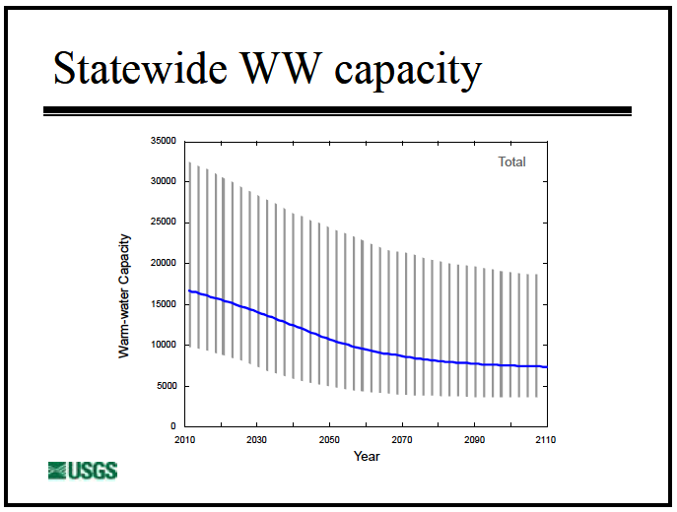
Source: Manatee Threats Analysis, Michael C. Runge, USGS, presented
to the Manatee Forum, May 2013
The CBM indicates the manatee will continue to increase until ultimately limited by warm water at or near 10,000.
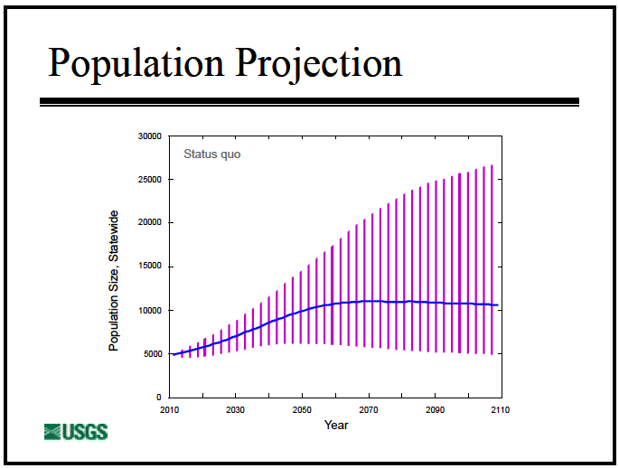
Source: Manatee Threats Analysis, Michael C. Runge, USGS, presented
to the Manatee Forum, May 2013

But the IHA study establishes that the OSP, limited by available SAV is considerably less than the CC. All indications are that it is highly probable that current trends in the manatee populations will continue unbounded to the CC, surpassing the OSP, without some other intervention.

If the manatee population increases beyond OSP, the impact to the habitat ecosystem is significant.

This risk is unacceptable and must be managed. Unless we wish to sit back and allow this outcome to occur, we need to reclassify the manatee to Recovered in order to institute management decisions, policy and regulations to prevent this potentially catastrophic occurrence. But because we have continued to classify the manatee as Endangered based more on pressure form special interest than science, we now find ourselves in an ironic situation where we continue to mange the extremely unlikely and completely acceptable risk of extinction and completely ignore the more likely and worse risk of overpopulation.

The overarching public perception of the manatee is that it is completely harmless with no natural enemies and no adverse consequence. We can thank the Save the Manatee Club for doing such an excellent job of selling manatee endangerment to the masses. But as is the case with any species, there is a population level where the numbers make this notion erroneous. If the manatee is allowed to exceed the OSP and over-pressure the available SAV in the ecosystem, especially our fragile coastal estuaries which are so critical to the life cycle of numerous in-shore and off shore species, we have made a critical management mistake. The unacceptability of the risk of overpopulation demands mitigation. This starts with reclassification of the species. The best available science demands reclassification, even in the face of popular opinion to the contrary.
Consequence to the ecosystem of manatee exceeding OSP

likelhood of manatee exceeding OSP
nt with

